**Setup:**

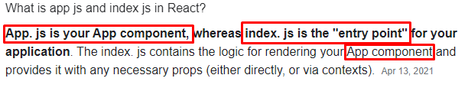

***index.js***

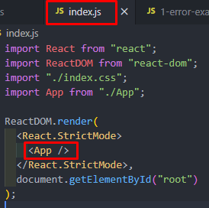

***App.js***

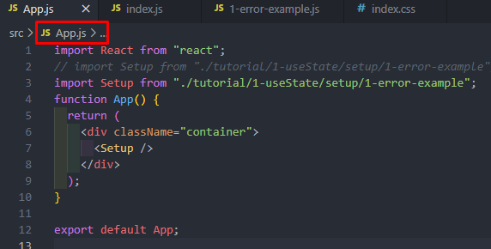

***1-error-example.js***

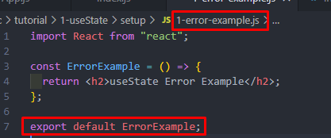

What we export (error-example.js) file will be received by any name. Here in App.js, it is received by Setup. We can use different names here.

**useState-Simple Use Case:**

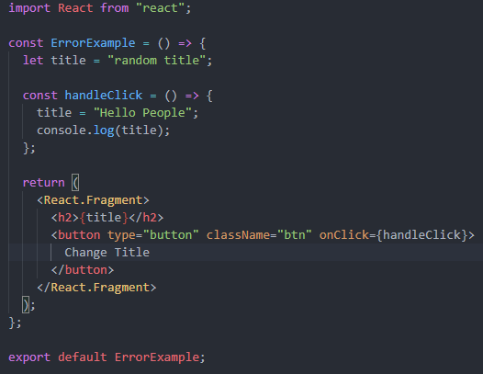  


If we click the change title button then we see,

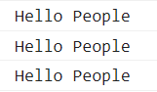

But no change on the document. The title was the same as the previous one. So we use useState.

**useState- Basics:**

1. useState is a function.
2. The React useState Hook **allows us to track state in a function component**. State generally refers to data or properties that need to be tracked in an application.
3. useState returns an array

Ekhane amra dekhbo j jokhon button e click korbo tokhon kivabe title ti document e change hoye jai.

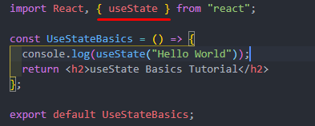



We get an array.

In useState array, the first element is the value, and the second element is the function.

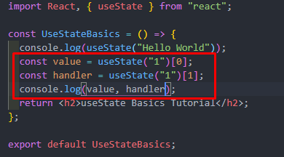



** Array Destructuring is needed in the next





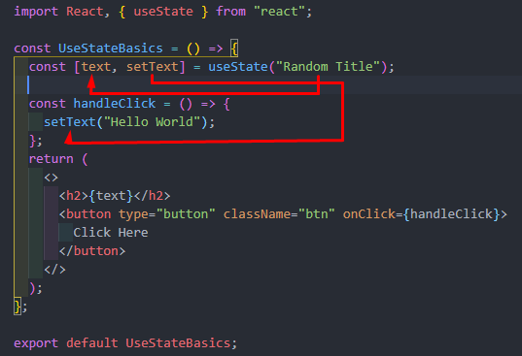

Here, Random Title text is set in the text variable. And later when we click( onClick), handleClick function comes into play, and into the function, the setText which comes from the useState plays its role. This function can take anything and pass it to the variable (text)

 After Click

Now, applied a condition here,

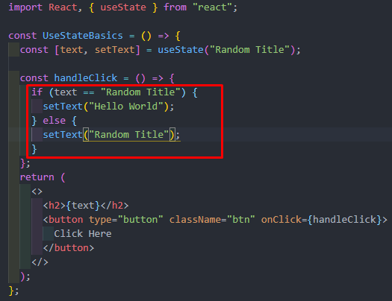

**useState Rules:**

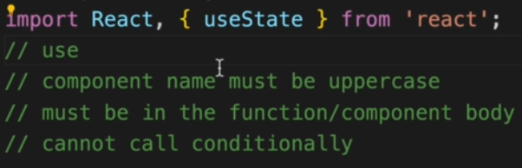

*** UseState er main line ti kono condition er mddhe use korbo na.

**useState Array Example:**

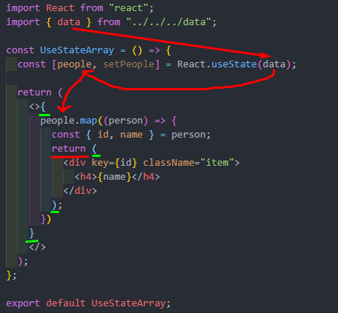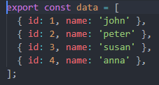

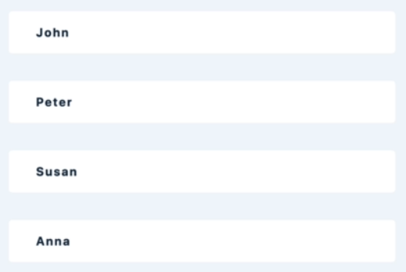

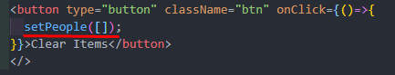

Here, When we click the button then an empty array is set into the setPeople function. Then all items will be cleared.

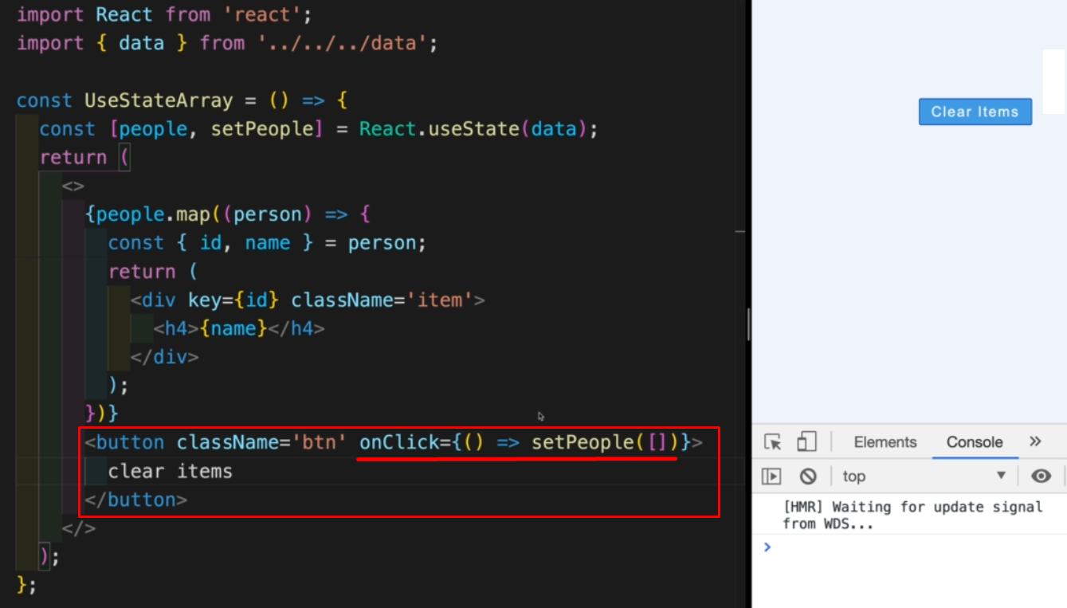

onClick function er moddhe setPeople shob empty kore dilam. Tai Clear Items button e click korar por,shob elements hawa hoye gelo.

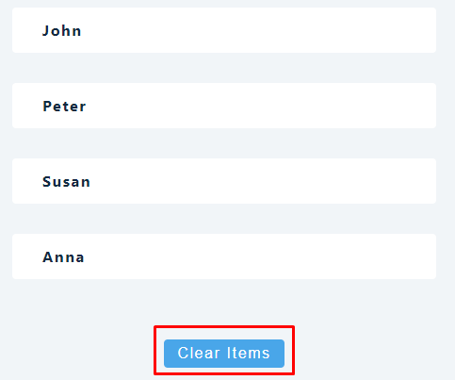

Now Individula item delete korte jeta korbo:

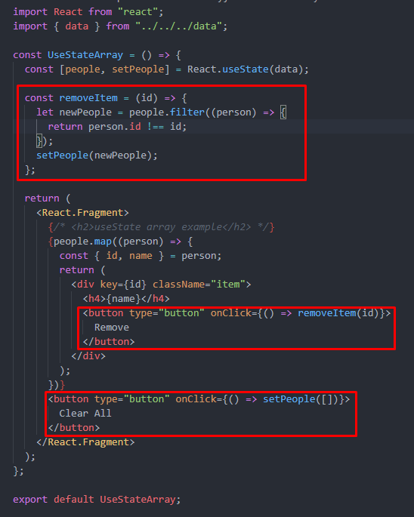

Or,

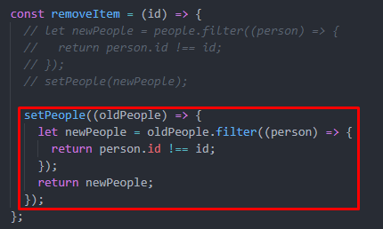

**useState-Object:**

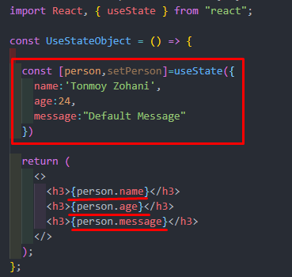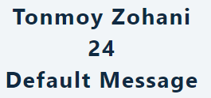

Now, If we want to change the message by using a button then,

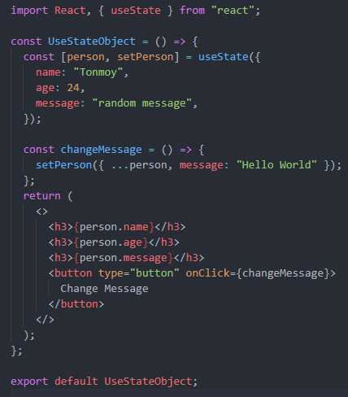

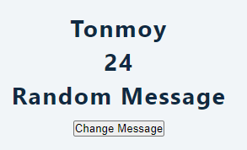 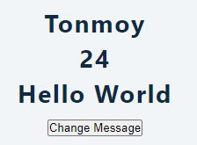

Now, add a little bit of spicy,

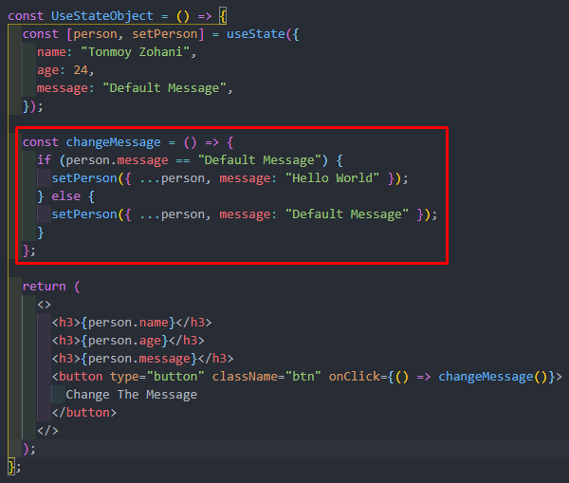

**useState- Multi-State Variables:**

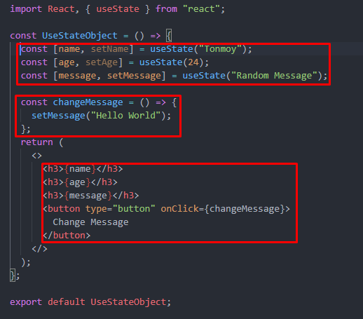

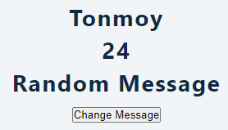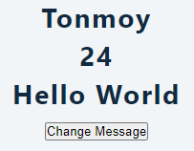

**Simple Counter:**

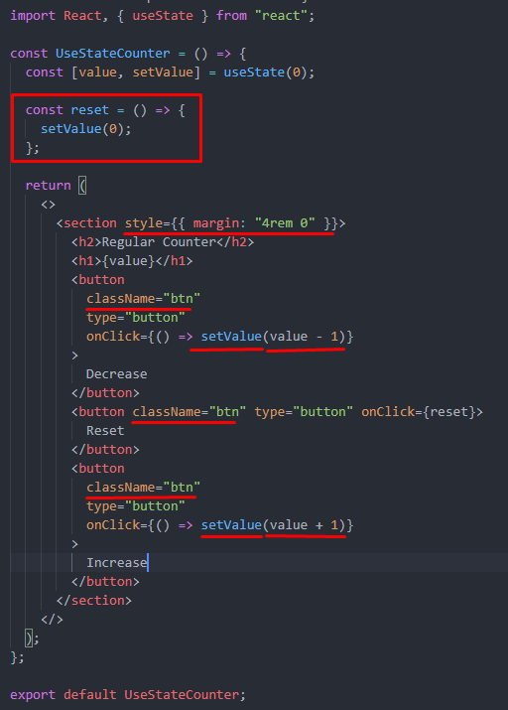

import React, { useState } from "react";

const UseStateCounter = () => {

const [value, setValue] = useState(0);

const reset = () => {

setValue((prevValue) => {

return (prevValue = 0); // Ekhane previous value jeta sheta use kora hoyeche

});

};

const complexIncrease = () => {

setTimeout(() => {

setValue((prevState) => { // Ekhane previous value jeta sheta use kora hoyeche

return prevState + 1; // shei value tar sathe 1 add kore return kora hoyeche

});

}, 2000);

};

return (

<>

<section style={{ margin: "4rem 0" }}>

<h2>Regular Counter</h2>

<h1>{value}</h1>

<button

className="btn"

type="button"

onClick={() => setValue(value - 1)}

>

Decrease

</button>

<button className="btn" type="button" onClick={reset}>

Reset

</button>

<button

className="btn"

type="button"

onClick={() => setValue(value + 1)}

>

Increase

</button>

</section>

<section style={{ margin: "4rem 0" }}>

<h2>Regular Counter</h2>

<h1>{value}</h1>

<button className="btn" type="button" onClick={complexIncrease}>

Increase Later

</button>

</section>

</>

);

};

export default UseStateCounter;